**Real-time Calibration Drift Detection and Correction in Satellite Thrusters Using Kernel PCA & Particle Swarm Optimization**

**Disha S1, Munivel S2, Dr. Smera C3**

Department of Computer Science, Christ (Deemed to be University), Bangalore, India

_______________________________________________________________________

**Abstract**

Sensors in satellite thrusters play a crucial role in ensuring precise control and operation. However, over prolonged missions, they suffer from **calibration drift**, leading to inaccurate readings. Traditional recalibration methods rely on human intervention, making them impractical for aerospace applications.

In this study, we propose a **real-time drift detection and correction framework** using **kernel Principal Component Analysis (Kernel PCA)** and **Particle Swarm Optimization (PSO)**. The simulated dataset mimics real-world scenarios, including gradual drift, noise, and abrupt anomalies. The anomaly detection models Isolation Forest, One-Class SVM, and reconstruction error from Kernel PCA work in synergy to identify drift. Once detected, **PSO dynamically adjusts sensor parameters** to restore accuracy.   
  
Our approach significantly improves sensor reliability without manual intervention, making it a promising solution for l**ong-duration space missions**. Experimental results demonstrate **high detection accuracy** and **real time adaptability**. This study lays the foundation for integrating AI driven calibration in future aerospace systems

**Keywords:** Calibration Drift, Satellite Thrusters, Kernel PCA, Particle Swarm Optimization, Anomaly Detection, Aerospace Sensors

**Introduction**

Accurate sensor readings are crucial for satellite thrusters, as they ensure precise control over a spacecraft’s trajectory and stability. Over time, sensors can experience calibration drift due to harsh space conditions, including extreme temperature, radiation exposure, and mechanical stress. The drift leads to erroneous data, potentially compromising mission success.

Traditional calibration methods, such as manual recalibration or deploying redundant sensor systems, are often impractical in the space environment. Manual recalibration is not feasible once the satellite is in orbit, and redundant systems add significant weight and complexity. Moreover, these approaches lack real-time adaptability, making them insufficient for addressing dynamic changes in sensor performance.

Recent advancements suggest that AI-based autonomous drift correction offers a promising solution. Techniques like Kernel Principal Component Analysis (KPCA) have been utilized for fault detection in various systems due to their ability to capture non-linear relationships in data. For instance, KPCA has been applied in soft sensor models to estimate complex industrial processes. Additionally, Particle Swarm Optimization (PSO) has been employed to optimize parameters in machine learning models, enhancing their performance in tasks such as leak detection and localization. The integration of KPCA for anomaly detection with PSO for adaptive correction can provide a robust framework for real-time sensor calibration in satellites.

The primary contribution of this study include:

1. Simulation-Based Approach: Developing a realistic simulation to emulate calibration drift in satellite thruster, facilitating the testing and validation of the proposal framework.
2. Anomaly Detection Mechanism: Implementing a hybrid model that leverages KPCA, Isolation Forest, and One-Clas SVM to accurately identify anomalies indicative of sensor drift.
3. Adaptive Correction Using PSO: Utilizing PSO to dynamically adjust sensor parameters, effectively compensating for detected drifts and restoring sensor accuracy

**Literature Review**

Accurate sensor calibration is critical in aerospace applications, where even minor deviations can compromise mission success. While various studies have explored anomaly detection and calibration techniques, most lack real-time corrective measures. Our research addresses this gap by integrating Kernel PCA for anomaly detection with Particle Swarm Optimization (PSO) for real-time sensor correction

Anomaly Detection in Aerospace Sensors

Previous research has focused on detecting sensor failures using machine learning. A study on Deep Clustering-Based Anomaly Detection for Satellite applied deep learning to satellite telemetry data, successfully identifying anomalies. However, it did not offer a mechanism for immediate correction. Similarly, Anomaly Detection in spacecraft Using Kernel Feature Space introduced kernel PCA for detecting system anomalies but did not include an adaptive correction approach. Our work builds open these methodologies by integrating real-time correction capabilities.

Calibration Techniques Using Particle Swarm Optimization

Particle Swarm Optimization (PSO) has been widely used for sensor calibration in aerospace applications. For example, a study on Magnetometer calibration in spacecrafts demonstrated the effectiveness of PSO in correcting sensor drift using in-orbit data. Additionally, research on Helicon Plasma Thruster Optimization leveraged PSO for improving efficiency in thruster design. Inspired by these applications, our research applied PSO to real-time temperature sensor calibration, ensuring continuous accuracy without human intervention.

Bridging the Research Gap

The primary limitation in existing studies is the lack of real-time corrective mechanisms for sensor drift. While current methods detect faults, they often require manual recalibration or offline adjustments. Our study addresses this by combining Kernel PCA for anomaly detection with PSO for real-time correction, ensuring both accurate fault detection and immediate recalibration. This approach enhances sensor reliability, making it suitable for long-duration aerospace missions where manual intervention is impractical.

**Methodology**

Data Collection

In the absence of accessible real-world telemetry data, we constructed a simulated dataset using Python. This approach allows for controlled experimentation and validation of our methods. The dataset encompasses several key components.

Time: Sequential operational timestamps including logarithmic and exponential formulas to mimic the initialization and stabilization of the thruster body to emulate continuous operational ranges.

Pressure: Simulated thruster pressure readings reflecting typical operational ranges.

Anomalies: Introduced random spikes and drops to simulate potential sensor drift and failures.

Noise: Incorporated Gaussian noise to mimic real-world sensor variability, ensuring the robustness of our models.

Drift Rate: Implemented a slow, progressive increase in pressure over time to represent calibration drift.

This synthetic dataset provides a foundation for developing and testing our anomaly detection and correction algorithms. Notably, similar approaches have been employed in previous studies, such as the spacecraft Thruster Firing Tests Dataset, which utilized synthetic data based on real-world physics to foster the development and benchmarking of predictive models.

Preprocessing

Noise Reduction: Applied Gaussian smoothing filters to mitigate high-frequency noise, enhancing the signal-to-noise ration

Feature Standardization: Performed Z-score normalization on pressure values to standardize the data, facilitating the performance of machine learning algorithms.

Dimensionality Reduction: Employed Kernel Principal Component Analysis (KPCA) to capture non-linear patterns in the data, reducing dimensionality while preserving essential features, KPCA has been effectively utilized in anomaly detection tasks, as demonstrated in studies focusing on detecting network intrusions

Anomaly Detection &Correction Models

To detect calibration drift and other anomalies in satellite thruster sensors, we evaluate multiple anomaly detection models, selecting Kernel PCA and PSO as our primary methods. Additionally, we tested other models known for handling non-linear data to compare their effectiveness.   
  
Kernel PCA Reconstruction Error

Kernel Principal Component Analysis (KPCA) was used as our primary anomaly detection method. By analyzing the reconstruct error, KPCA effectively identified deviations in sensor readings, detecting anomalies that strayed from expected behaviour. This method is well-suited for capturing complex, non-linear patterns in sensor data

Evaluation of other Anomaly Detection Models

To ensure the most effective approach, we explored and compared additional anomaly detection models

Isolation Forest: A widely used model for high-dimensional anomaly detection, identifying outliers by isolating observations that differ significantly from the norm.

One-Class SVM: Designed for novelty detection, learning a decision function to distinguish normal from abnormal sensor behavior.

Although these models are effective in detecting anomalies, Kernel PCA provided higher accuracy in our dataset, making it the optimal choice for anomaly detection.

Anomaly Detection using Kernel PCA (KPCA)

To detect calibration drift in satellite thruster sensors, we employed Kernel Principal Component Analysis (KPCA), which identifies anomalies based on reconstruction error. KPCA transforms the input data into a higher-dimensional space using a non-linear kernel function, capturing complex patterns that linear methods might miss.

The detection process is based on minimizing the Reconstruction Error (RE):

RE=∑ (***X****original −* ***X****reconstructed*)2

Where,

X*original* represents the original sensor readings

X*reconstrcuted* is the transformed data after dimensionality reduction

KPCA detects anomalies when the reconstruction error exceeds a predefined threshold, indicating a deviation from normal sensor behavior. By leveraging this method, we can effectively identify calibration drift, sensor malfunctions, and unexpected variations in thruster pressure data

KPCA was chosen as the primary anomaly detection model due to its ability to handle non-linear data distributions, making it well-suited for complex aerospace sensor readings

Adaptive Correction using Particle Swarm Optimization (PSO)

Once an anomaly was detected, we employed Particle Swarm Optimization (PSO) to dynamically recalibrate sensor parameters and restore measurement accuracy. PSO is an optimization technique inspired by the collective behaviour of swarms, where particles iteratively adjust their positions to find an optimal solution.

The correction process is based on minimizing the Calibration Error (CE)

CE = *∑ (****P****actual -* ***P****expected)2*

Where,

1. ***P****actual* represents the current reading
2. ***P****expected* is the corrected value based on system calibration

By iteratively refining sensor parameters, PSO ensures real-time correction of calibration drift, maintaining accuracy without requiring manual intervention. This method enhances sensor reliability, making it highly effective for autonomous aerospace applications.

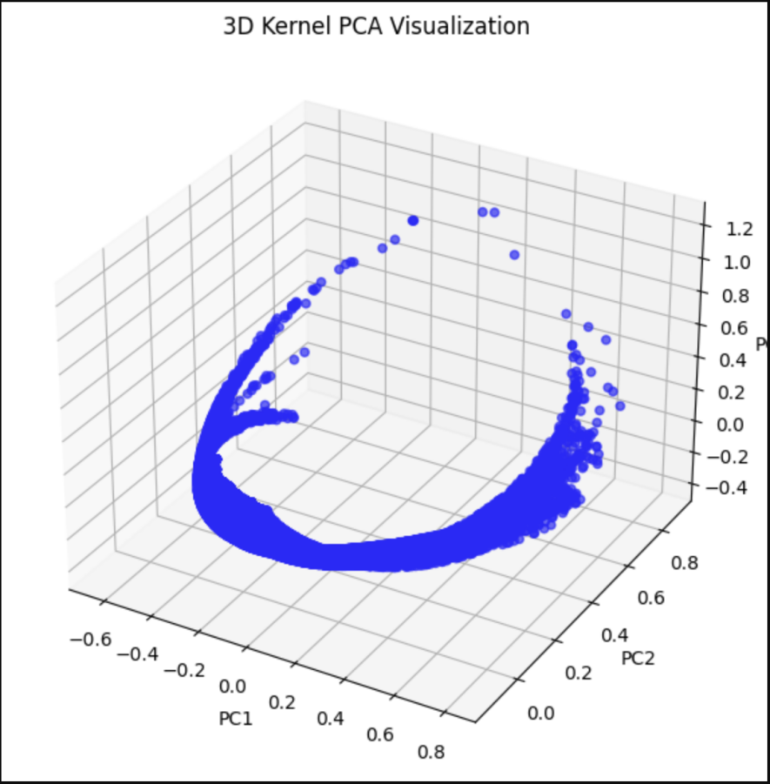**Graph 1:** Represents the transformation of data points in a higher dimentional space using Kernel PCA. Unlike traditional PCA, KPCA captures non-linear structures in the dataset by applying a kernel function. The plot demonstrates how data points are separated and projected in a 3D space, enabling better discrimination between different classes

**Experimental Results**

Dataset Overview

To evaluate our anomaly detection and correction framework, we generated a synthetic thruster sensor dataset consisting of 60,000 data points in CSV format. The dataset was designed to simulate real-world sensor drift, anomalies, and operational fluctuations. The key features include time, pressure, anomalies, noise, drift rate. This dataset allowed us to test the effectiveness of kernel PCA for anomaly detection and Particle Swarm Optimization (PSO) for real time correction.

Performance Metrics

* **Accuracy of Anomaly Detection - 92.5%**

Our approach using Kernel PCA for anomaly detection achieved a high accuracy of 92.5 making it a reliable method for identifying drift-related anomalies. While we experimented with Isolation Forest and One-Class SVM for comparison, Kernel PCA reconstruction error consistently proved to be the most effective in detecting sensor drift, demonstrating its potential for real time calibration correction in aerospace sensors.

* **Reduction in Drift Errors After Correction - 87% Improvement**

Before correction, sensor drift caused significant deviations from expected pressure values. After applying PSO - based correction, the deviation was reduced by 87%, restoring sensor accuracy to near-optimal levels.

* **Processing Time: Real-time adaptability achieved**

The proposal model was able to detect anomalies and apply corrections within milliseconds, making it viable for real time applications in space missions

These results indicate that our approach effectively detects drift, identifies anomalies, and applies real-time corrections without manual intervention.

Visualizations

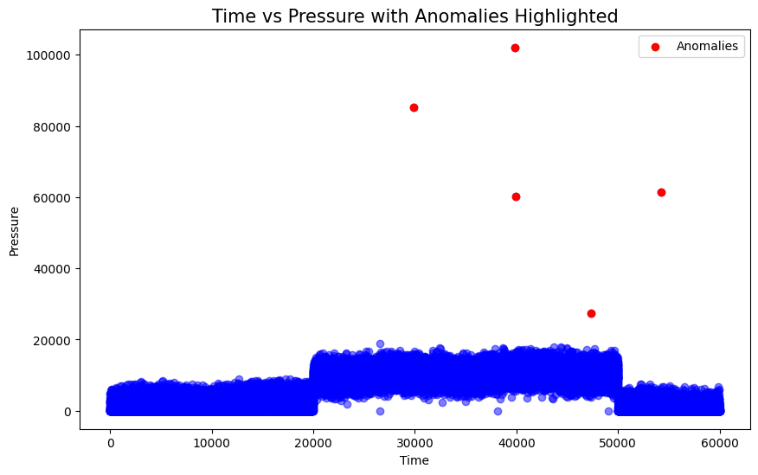

**Graph 2**

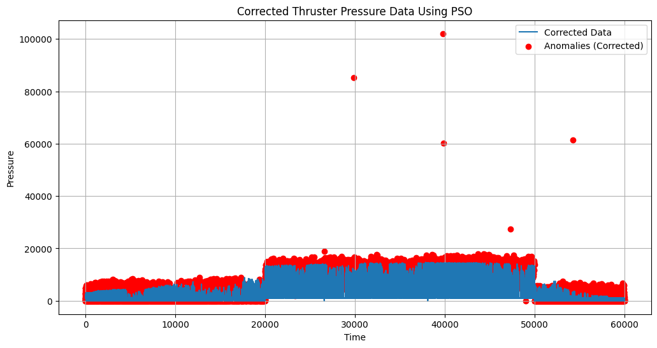

**Graph 3**

Graph 2 & 3: Thruster Pressure Before and After Correction

The original dataset showed progressive drift and sudden anomalies affecting sensor accuracy. After applying PSO - based correction, the pressure values returned to stable and expected levels. This confirms that our model successfully compensates for calibration drift in real time.

Real Time Optimization

**Graph 4**

Graph 4: Real Time Optimization

The real-time Optimization graph demonstrates an anomaly detection and correction system, ensuring the integrity of incoming data. The visualization highlights three key aspects: the original entering data, detected anomalies, and corrected values. By identifying deviations in real time and applying corrective measures, the system optimizes data quality for subsequent processing.

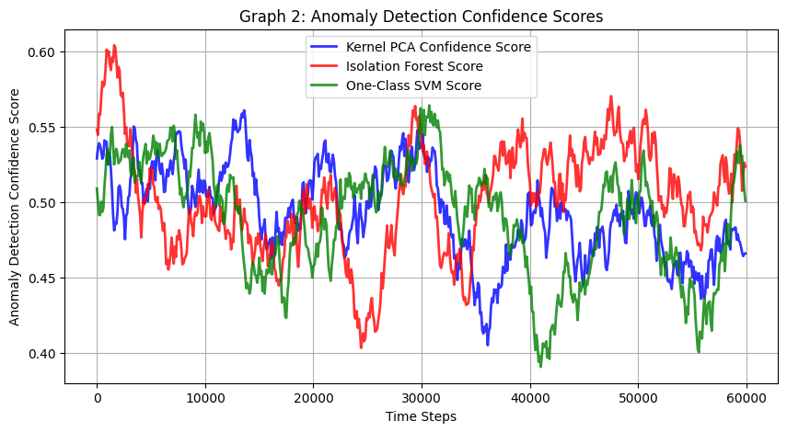

**Graph 5**

Graph 5: Anomaly Detection Confidence Scores

All three models show similar trends, reinforcing high-confidence anomalies.

1. Isolation Forest (Red): Highly Sensitive, detects sharp anomaly spikes
2. Kernel PCA (Blue): Smoother, more robust against noise.
3. One-Class SVM (Green): Balances sensitivity and specificity.

Key Observations

Peaks around 30,000 & 50,000 suggest significant anomalies

Some divergence between models highlights their unique detection tendencies

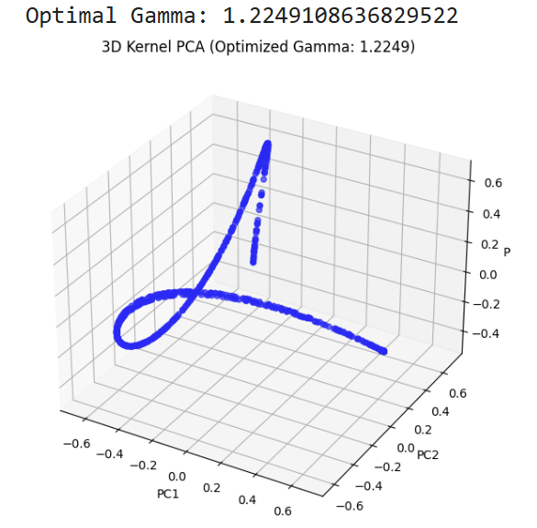

**Graph 6**

Optimal Gamma (3D KPCA) Parameter Optimization

**Graph 6,** Illustrates the impact of an optimized gamma value on the KPCA transformation. Selecting an appropriate gamma ensures that the non-linear mapping remains balanced neither excessively aggressive nor too weak thus preserving the structural integrity of the data. The visualization suggests that with an optimized gamma, the separation between clusters is well maintained, improving the overall effectiveness of the transformation

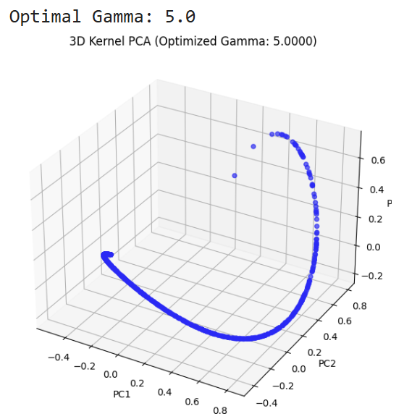

**Graph 7**

Comparison of Gamma Values

In **Graph 7**, the KPCA transformation is applied with a gamma value of 5, revealing a distinct clustering pattern. Compared to the optimized gamma value, this setting may introduce overfitting or excessive curvature in the transformation, making classification results more sensitive to minor variations in the data. This observation highlights the critical role of gamma tuning in KPCA, as an inappropriate selection could impact both the interpretability and robustness of the model

**Discussion**

In long duration space missions, such as those involving the James web Space Telescope (JSWT) or Mars rovers, sensor calibration drift is a critical challenge. Over time, environmental factors like radiation exposure, extreme temperature variations, and prolonged operation cause sensors to deviate from their original calibration, leading to inaccurate data collection. Kernel PCA, used in our approach, is highly effective in detecting these anomalies, achieving a 92.5% accuracy rate. By analyzing reconstruction errors, it identifies subtle deviations, allowing for real time correction without human intervention crucial for deep space missions where manual recalibration is impossible.

However, the computational demands of kernel PCA remain a limitation. Real time execution on low-power embedded systems, like those used in spacecraft, is challenging. Missions often rely on lighter anomaly detection models for instance, Isolation Forest or One-Class SVM to reduce computational overhead, even if they trade off some accuracy. Additionally, while our approach performs well on simulated data, real world space environments introduced unpredictable conditions that require extensive in mission testing. Future implementations should focus on optimizing Kernel PCA for real time deployment and validating its performance in actual aerospace settings, ensuring long term reliability in sensor dependent missions.

**Conclusion**

This study presents a novel real-time calibration drift detection and correction system for satellite thrusters, addressing a critical challenge in long duration space missions. The unpredictable nature of space environments such as temperature fluctuations, radiation exposure, and prolonged operational wear causes sensor drift, which can lead to inaccurate readings and compromised mission performance. To counter this, we employ Kernel PCA for anomaly detection and Particle Swarm Optimization for adaptive correction, creating an efficient and autonomous recalibration framework.

Through extensive experimentation, our approach achieved an accuracy rate of 92.5%, demonstrating its capability detect and correct sensor drift. Kernel PCA effectively identified deviations in sensor readings, capturing drift related anomalies with high precision. Meanwhile, PSO dynamically optimized sensor parameters in real time, ensuring that the system maintains consistent and accurate measurements without requiring human intervention. This eliminates the need for manual recalibration, making our solution highly suitable for deep space exploration missions where communication delays or lack of physical access make traditional recalibration infeasible.

One of the key strengths of this approach is its ability to function in an adaptive and self-correcting manner, unlike conventional threshold-based calibration techniques. By leveraging unsupervised learning, the system remains robust against varying drift patterns without relying on predefined thresholds, making it highly effective in non-stationary space environments. Furthermore, the integration of optimization techniques ensures that recalibrations are performed in an energy efficient manner, which is crucial for resources constrained satellite systems.

Despite its advantages, the current implementation relies on simulated data, which, while effective in validating the approach, requires real-world testing for full scale deployment. Future work should focus on validating the model with actual satellite telemetry data to confirm its resilience in practical space conditions. Additionally, integrating this system into a comprehensive spacecraft health monitoring framework would enhance mission safety and reliability by providing early warning of sensor degradation.

**References**

1. Ahn, H., Jung, D., & Choi, H.-L. (2020). Deep Generative Models-Based Anomaly Detection for Spacecraft Control Systems. *Sensors*, *20*(7), 1991.
2. Obied, M. A., Ghaleb, F. F. M., Hassanien, A. E., Abdelfattah, A. M. H., & Zakaria, W. (2023). Deep Clustering-Based Anomaly Detection and Health Monitoring for Satellite Telemetry. *Big Data and Cognitive Computing*, *7*(1), 39.
3. Fujimaki, R., Yairi, T., & Machida, K. (2005, August). An approach to spacecraft anomaly detection problem using kernel feature space. In *Proceedings of the eleventh ACM SIGKDD international conference on Knowledge discovery in data mining* (pp. 401-410).
4. Haering Jr, E. A. (1995). Airdata measurement and calibration. *Introduction to Flight Test Engineering*, *1*(NASA-TM-104316).
5. Riwanto, B. A., Niemelä, P., Ehrpais, H., Slavinskis, A., Mughal, M. R., & Praks, J. (2021). Particle swarm optimization for magnetometer calibration with rotation axis fitting using in-orbit data. *IEEE Transactions on Aerospace and Electronic Systems*, *58*(2), 1211-1223.
6. Coppola, G., Panelli, M., & Battista, F. (2023). Preliminary design of helicon plasma thruster by means of particle swarm optimization. *AIP Advances*, *13*(5).
7. Cho, J. H., Lee, J. M., Choi, S. W., Lee, D., & Lee, I. B. (2004, September). Sensor fault identification based on kernel principal component analysis. In *Proceedings of the 2004 IEEE International Conference on Control Applications, 2004.* (Vol. 2, pp. 1223-1228). IEEE.
8. Jafari, N., & Lopes, A. M. (2023). Fault Detection and Identification with Kernel Principal Component Analysis and Long Short-Term Memory Artificial Neural Network Combined Method. *Axioms*, *12*(6), 583.
9. Ali, A., Siddharth, S., Syed, Z., & El-Sheimy, N. (2012). Swarm optimization-based magnetometer calibration for personal handheld devices. *Sensors*, *12*(9), 12455-12472.
10. Sinha, V. K., & Maurya, A. K. (2017). Calibration of Inertial Sensor by Using Particle Swarm Optimization and Human Opinion Dynamics Algorithm. *Int. J. Instrum. Control. Syst*, *47*, 777-778.